**TABLE CREATION:**

CREATE TABLE EventRequest

(EventNo VARCHAR2(8) CONSTRAINT EventNoNotNull NOT NULL,

DateHeld DATE CONSTRAINT DateHeldNotNull NOT NULL,

DateReq DATE CONSTRAINT DateReqNotNull NOT NULL,

CustNo VARCHAR2(8) CONSTRAINT ECustNoNotNull NOT NULL,

FacNo VARCHAR2(8) CONSTRAINT EFacNoNotNull NOT NULL,

DateAuth DATE,

Status VARCHAR2(15) CONSTRAINT StatusNotNull NOT NULL,

EstCost FLOAT CONSTRAINT EstCostNotNull NOT NULL,

EstAudience INT CONSTRAINT EstAudienceNotNull NOT NULL,

BudNo VARCHAR2(20),

CONSTRAINT CHECK_ESTAUDIENCE CHECK (EstAudience>0),

CONSTRAINT CHECK_STATUS CHECK (Status IN ('Pending', 'Denied', 'Approved' )),

CONSTRAINT PK_EVENTREQUEST PRIMARY KEY (EventNo),

CONSTRAINT FK_ECUSTNO FOREIGN KEY (CustNo) REFERENCES CUSTOMER (CustNo),

CONSTRAINT FK_EFACNO FOREIGN KEY (FacNo) REFERENCES FACILITY (FacNo));

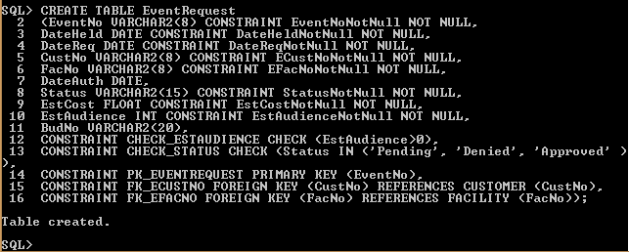

**SELECT STATEMENT:**

